2016 Community Service Project

The attorneys and staff of RHP volunteered their time at EOS Therapeutic Riding Center in Bloomsburg on Oct. 29, 2016. It was a beautiful day to help EOS winterize their buildings and grounds. We also delivered our clients’ generous donations of cash, office supplies, tack and horse feed. Take a look at our photos!

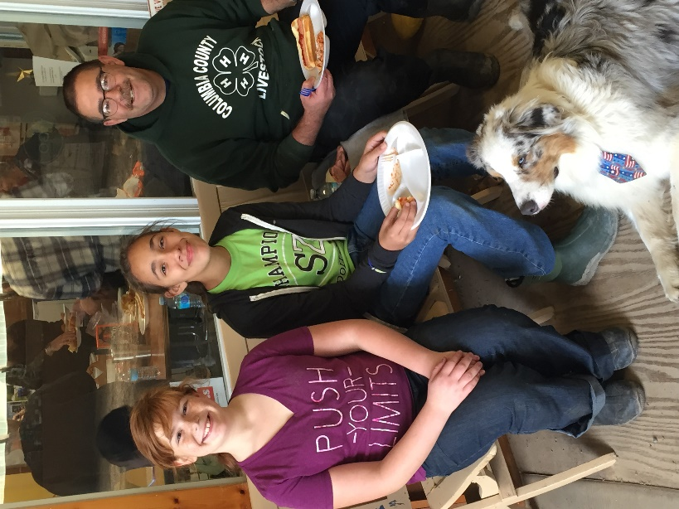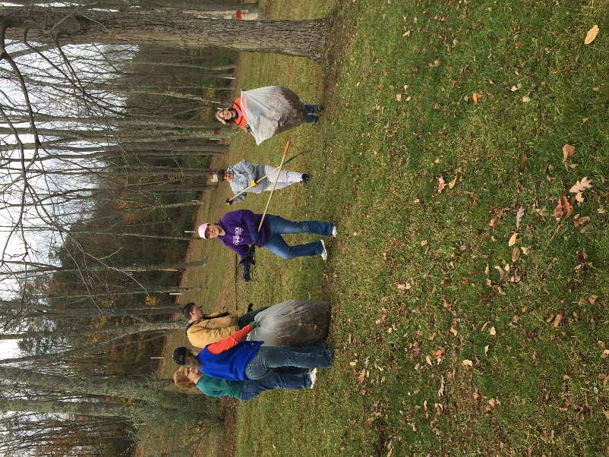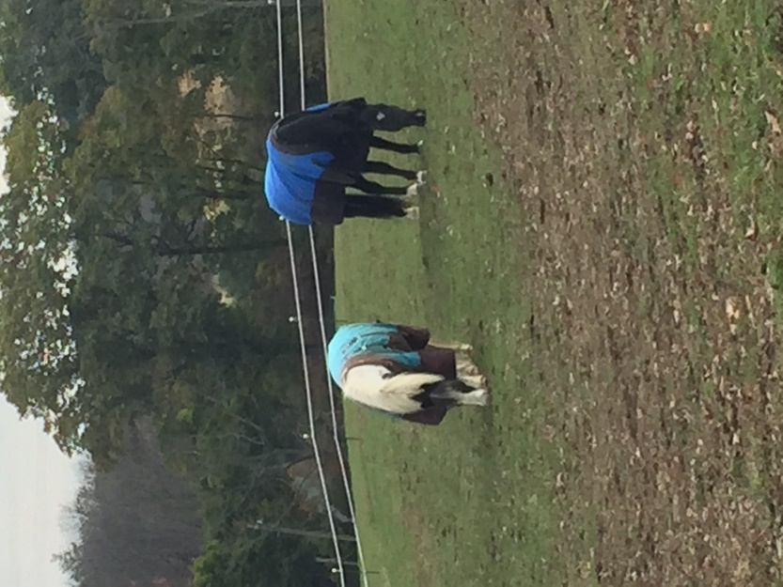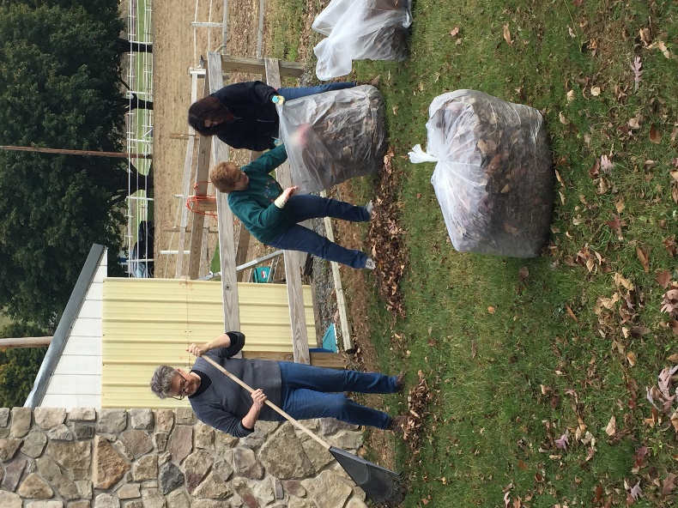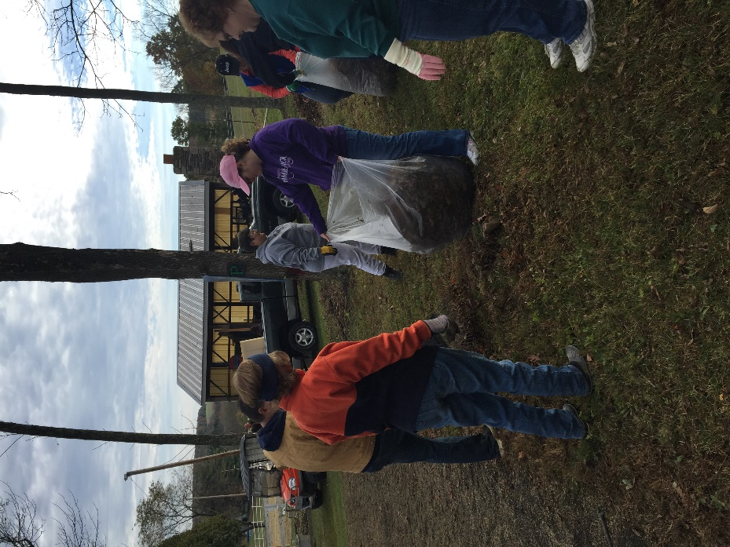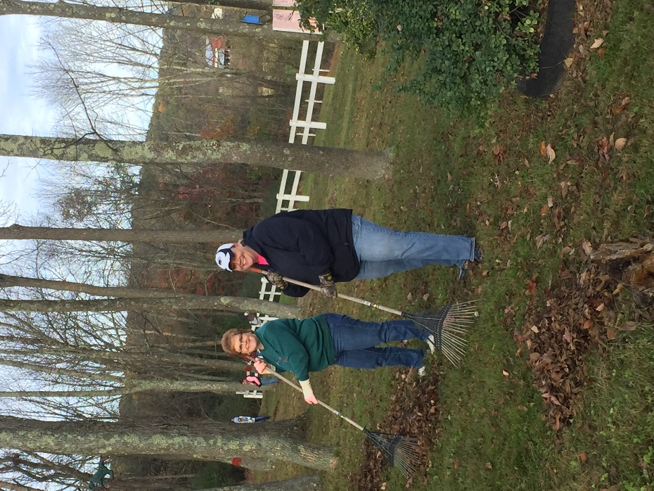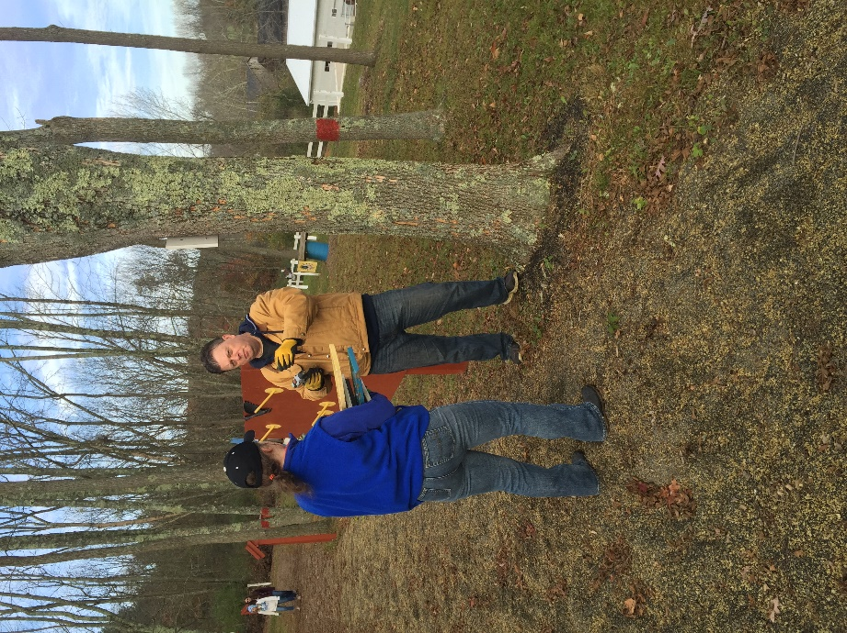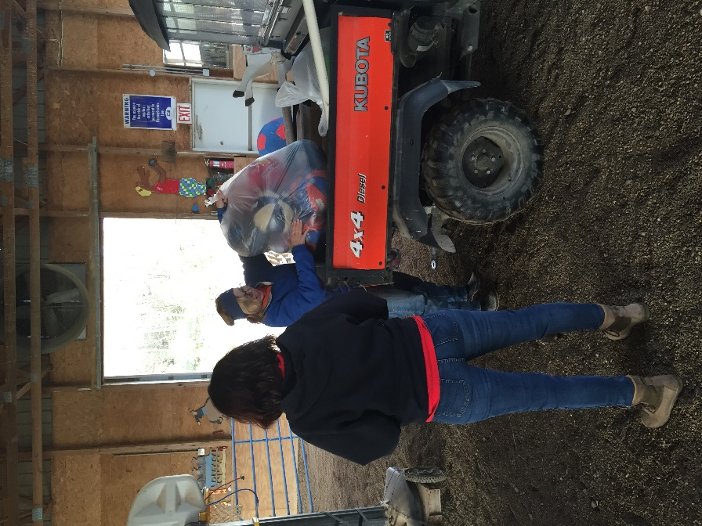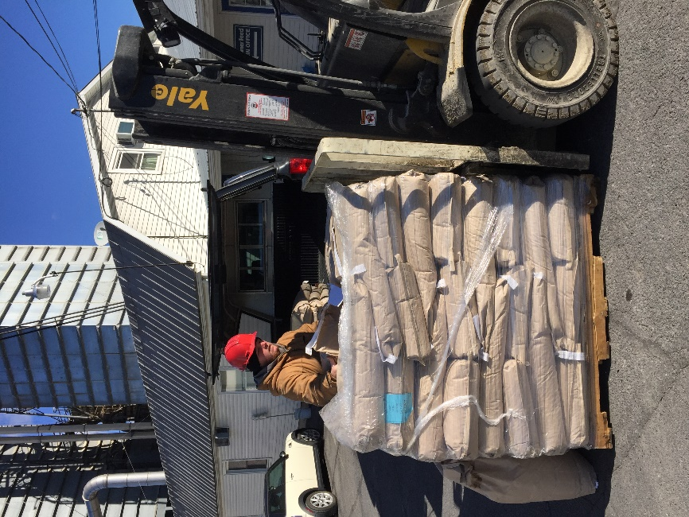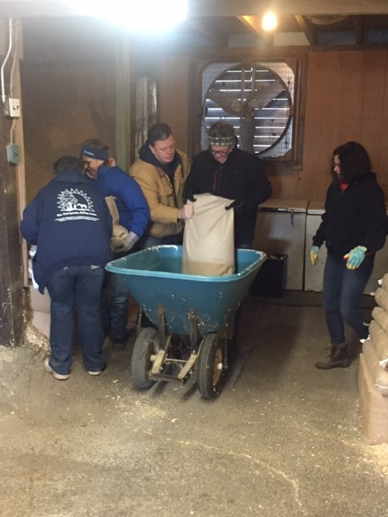

Kreamer Feed’s generous donation -
500 lbs. of alfalfa pellets!

